1.1 Networks, Packets, and Protocols

A computer network consists of machines interconnected by communication channels. We call these machines hosts and routers. Hosts are computers that run applications such as your Web browser, your IM agent, or a file-sharing program. The application programs running on hosts are the real “users” of the network. Routers are machines whose job is to relay, or forward, information from one communication channel to another. They may run programs but typically do not run application programs. For our purposes, a communication channel is a means of conveying sequences of bytes from one host to another; it may be a wired (e.g., Ethernet), a wireless (e.g., WiFi), or other connection.

A protocol is an agreement about the packets exchanged by communicating programs and what they mean. A protocol tells how packets are structured—for example, where the destination information is located in the packet and how big it is—as well as how the information is to be interpreted. A protocol is usually designed to solve a specific problem using given capabilities. For example, the HyperText Transfer Protocol (HTTP) solves the problem of transferring hypertext objects between servers, where they are stored or generated, and Web browsers that make them visible and useful to users. Instant messaging protocols solve the problem of enabling two or more users to exchange brief text messages.

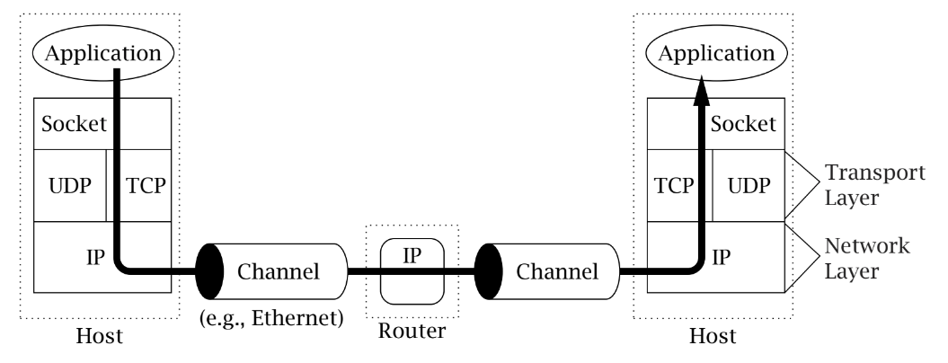

In TCP/IP, the bottom layer consists of the underlying communication channels—for example, Ethernet or dial-up modem connections. Those channels are used by the network layer, which deals with the problem of forwarding packets toward their destination.

1.2 About Addresses

Internet addresses are binary numbers. They come in two flavors, corresponding to the two versions of the Internet Protocol that have been standardized. The most common type is version 4 (“IPv4,” [14]); the other is version 6 (“IPv6,” [7]), which is just beginning to be deployed.IPv4 addresses are 32 bits long; because this is only enough to identify about 4 billion distinct destinations, they are not really big enough for today’s Internet. (That may seem like a lot, but because of the way they are allocated, many are wasted. More than half of the total address space has already been allocated.) For that reason, IPv6 was introduced. IPv6 addresses are128 bits long.

1.3 About names

Most likely you are accustomed to referring to hosts byname (e.g., host.example.com). How-ever, the Internet protocols deal with addresses (binary numbers), not names. You should understand that the use of names instead of addresses is a convenience feature that is independent of the basic service provided by TCP/IP—you can write and use TCP/IP applications without ever using a name. When you use a name to identify a communication endpoint, the system does some extra work to resolve the name into an address.

1.4 Clients and Servers

The terms client and server refer to these roles: the client program initiates communication, while the server program waits passively for and then responds to clients that contact it. Together, the client and server compose the application.

1.5 What is a socket?

A socket is an abstraction through which an application may send and receive data, in much the same way as an open file handle allows an application to read and write data to stable storage. A socket allows an application to plug in to the network and communicate with other applications that are plugged in to the same network.

Different types of sockets correspond to different underlying protocol suites and different stacks of protocols within a suite. The main types of sockets in TCP/IP today are stream sockets and datagram sockets. Stream sockets use TCP as the end-to-end protocol (with IP underneath) and thus provide a reliable byte-stream service. A TCP/IP stream socket represents one end of a TCP connection. Datagram sockets use UDP (again, with IP underneath) and thus provide a best-effort datagram service that applications can use to send individual messages up to about 65,500bytes in length.

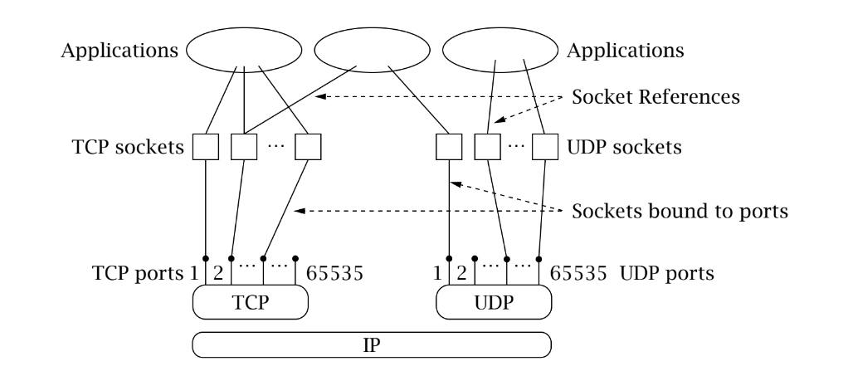

Figure 1.2 depicts the logical relationships among applications, socket abstractions,protocols, and port numbers within a single host.